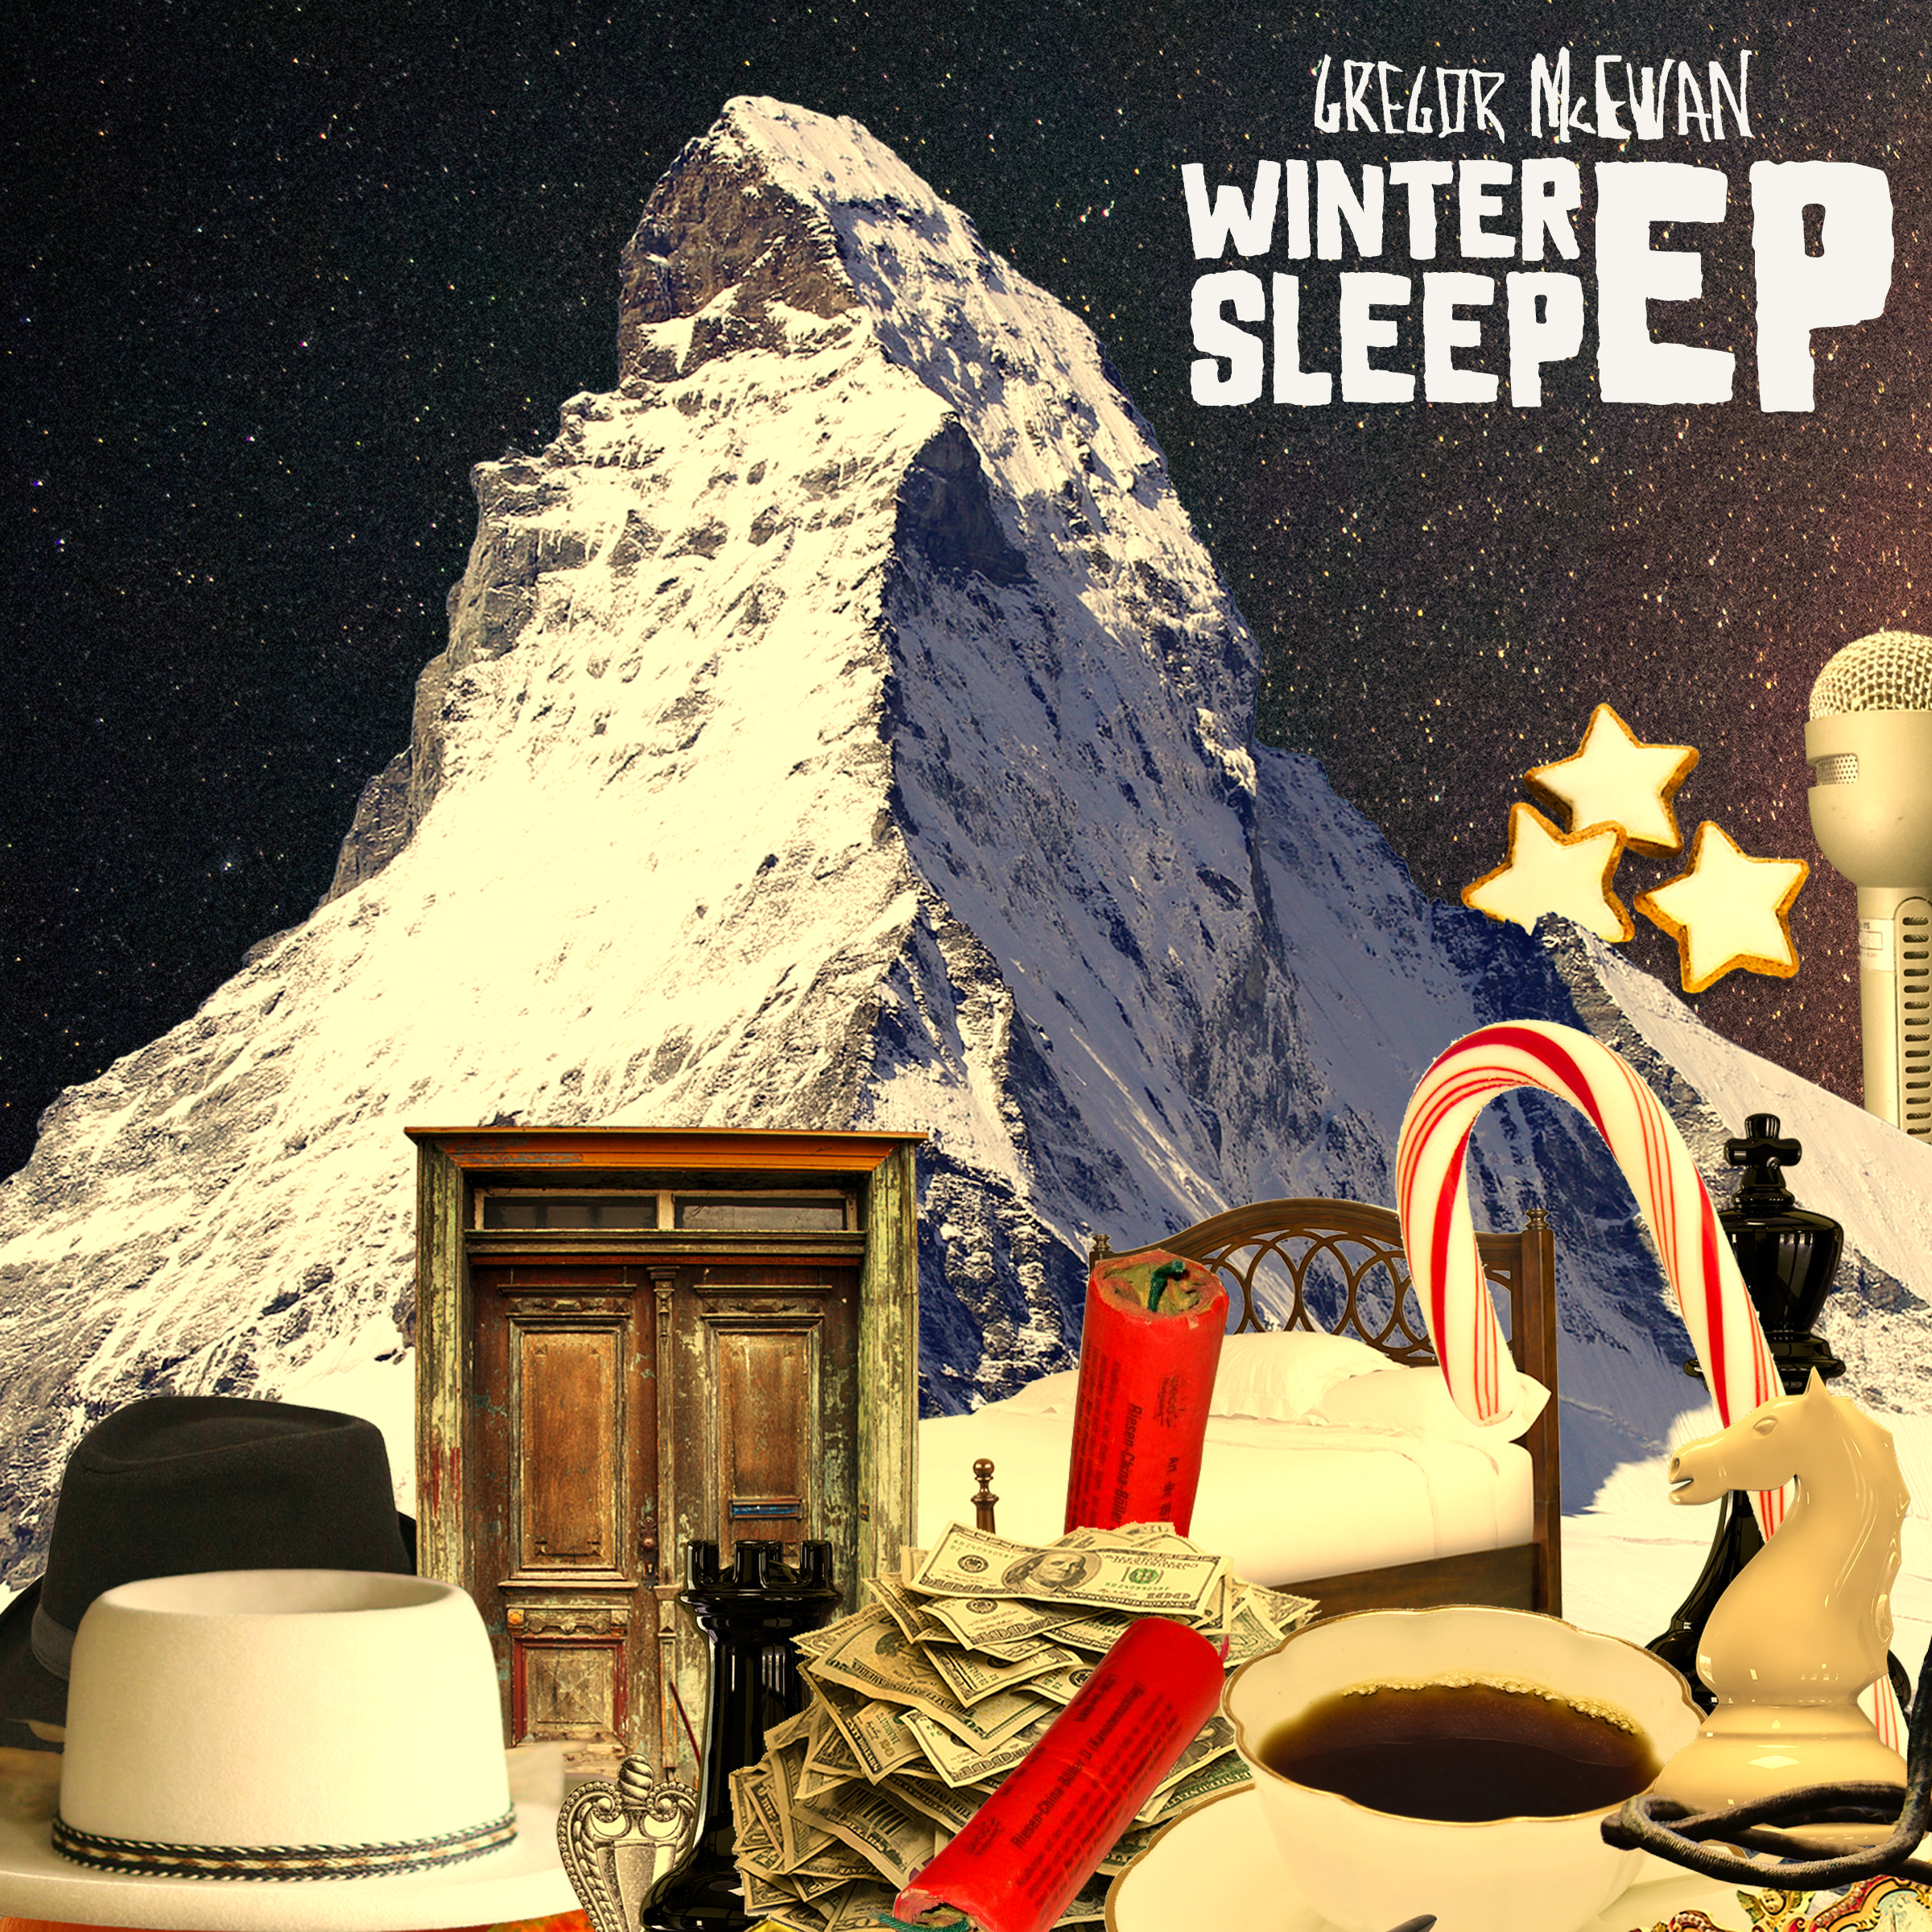  
  
GREGOR McEWAN – WINTER SLEEP EP (RD: 11/02/22)  
a press release by Kati von Schwerin

**Winter is here! Unfortunately without Christmas parties or Christmas markets, but with staying at home orders and contact restrictions. Actually, it would be awful if it weren't for art and culture (yes, they still exist...) to contemplate and dream away.**

**Winter is here... finally! Because with the "Winter Sleep EP" by Gregor McEwan, we get what we really need right now: Four beautiful songs that invite us to leave the daily hustle and bustle behind us with a warm drink and a warm woollen blanket and to reconcile a little with our winter blues. Because Black Friday is raging outside, in the slush and city madness, which is worth forgetting for a short while, as McEwan recommends in the dreamy "Lousy Lullaby". The city soul is comforted, while the accompanying video shows the musician in pyjamas and slippers, roaming sleepily through Berlin with a teddy bear under his arm (well worth seeing!). In the piano piece "New Year's Resolutions", Gregor McEwan also hopes for contemplation by addressing the horrors of New Year's Eve which are firecrackers, brawls and air pollution and which he also manifests musically at the end of the song. Instead, the alternative of good food and good company is convincingly advised ("Let's have a five-course meal instead | And then collapse into bed | Let's have a bottle of champagne | Gingerbread and candy cane | Let's have our friends around | When there are stars and waves to count"). He's right, and as long as it's 2G compliant, there's probably nothing better in these times than indulgence, as well as good for the heart and mind! Wrap up with your loved ones, chow down on biscuits, crumble into bed and get a little melancholy, like in the song "Sweets And Sadness", which had been in McEwan's drawer for a long time before the right time finally came to share this wintry pearl with the listeners. The title track "Winter Sleep", whose genesis can be traced back to the film "Cloud Atlas", certainly deserves special mention. In the film from 2012, people or souls are inseparably connected to each other regardless of space and time and thus meet again and again in the most diverse constellations. Winter as a mystical season, in which one thinks melancholically of the past and the ephemeral, puts cold and darkness over the mind and provides not only for vitamin D3 deficiency, but not infrequently also for philosophical maelstroms of thoughts. The heart becomes heavy because winter seems to lack what usually keeps us from going to bed with the big question of meaning. Then we miss those who are no longer there and we struggle with being. "If death is only a door | We strode through before | Time is only a trick | But I don't get it" sings Gregor McEwan in the unpretentiously arranged guitar song complete with record crackling and choir intro. The title track sounds somehow conciliatory and seems to want to say*: It's alright, you can't understand the rules of the game anyway.***

**And even if the "Winter Sleep EP" comes along with rather subdued arrangements and perfectly captures the gloom of this time of year, it still warms your heart, because Gregor McEwan's voice creates a comforting warmth that is often missed elsewhere.**

Tracklisting  
NEW YEAR'S RESOLUTIONS  
SWEETS AND SADNESS  
WINTER SLEEP  
LOUSY LULLABY  
  
with  
RUBY HARTBRICH, CYPRIAN PISKUREK & KONSTANTIN DÖBEN

ALL SONGS WRITTEN & COMPOSED BY GREGOR McEWAN

(FREIBANK MUSIC PUBLISHING)

PRODUCED & MIXED BY GREGOR McEWAN & THIES NEU

RECORDED & MASTERED BY THIES NEU AT TONBRAUEREI, BERLIN  
  
SUPPORTED BY INITIATIVE MUSIK gGMBH WITH PROJECT FUNDS FROM THE FEDERAL GOVERNMENT COMMISSIONER FOR CULTURE AND MEDIA

ARTWORK DESIGN BY GREGOR McEWAN

LOGO DESIGN BY OLGAUWAGA

LABEL RADIO PROMO PROMOTION PUBLISHING BOOKING SUPPORT  
   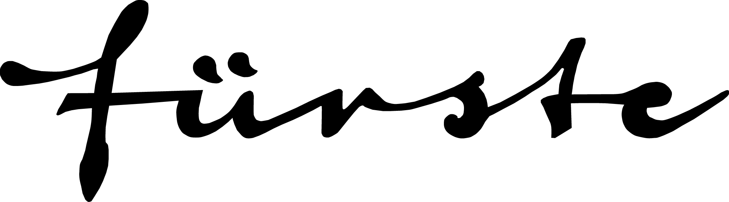   

ISA@STARGAZERRECORDS.DE CLAUSEN@FACTORY92.EU MELANIE.FUERSTE@WEB.DE INFO@FREIBANK.COM HAGEN@AMADIS.NET INITIATIVE-MUSIK.DE